Video Notes

Video 1: About Multimeter and it’s use

* It is used for measuring Current, voltage and Resistance by using two probes. We can use it for both AC and DC power.
* For the connection with the probes, jack in the black side with COM and red one with the desired side.
* For measuring resistance, connect the both side of resistor with two probes connected with the multimeter. But difference between measuring only resistor and built circuit resistor, we can see the different ohms from the same resistor. So measuring only resistor is more accurate.
* We can also check cable break by using it. When a cable connected with two probes, it won’t beep if the cable is broken. It will make beep sound when the circuit is complete or the cable is not broken
* For measuring voltage for DC power supply, connect red probe to the positive side and connect black probe with the negative side of the power source. Because we measure voltage in parallel circuit.
* For measuring current, we need an open circuit to connect the multimeter. If it measures larger amount of current than it’s capability, the fuse will be down.

Video 2: About controlling the brightness of LEDs

* LED can be dimmed with or without using Arduino. This microcontroller process is called PWM (Pulse, Width, Modulation).
* For the basics, LED is dimmed by changing the voltage. It can be done with potentiometer easily. Because, higher the voltage, lower the brightness of light, but it will then consume much current and eventually the LED will burn out. But lowering the voltage causes the LEDs to get lesser brightness.
* But lowering the voltage can be used, by switching the voltage between 0V to 5V. For example: 2.5V means the half of the brightness, 4V means little lesser brighter than the highest, 0V means the light gets off.
* With the use of the Arduino, connect the potentiometer as analog input and connect LED with any pin. Then in code, analogWrite can generate the value of potentiometer from 0 to 255. 0 means 0V and 255 means 5V. Thus, the LEDs brightness can be controlled.
* This can be done without the Arduino. It will be needed the ICs, Diodes, Capacitors.
* MOSFET can be used for higher voltage controlling.

Video 3: Programming ATtiny by using Arduino

* ATtiny 85 is a microcontroller, it can be programmed by Arduino, also Arduino contains ATmega 328p which is also a microcontroller.
* ATtiny 85 contains 5 IOs, 8kb memory. It is used for lights blinking animation.
* Arduino software version 1.0.5 to be installed because it doesn’t work on the newer version.
* Then download the board data for ATtiny. Then copy and paste it to the designated location of the Arduino.
* Select the board ATtiny 84 and upload Arduino ISP sketch
* As for the ATtiny, Pin 4 is ground, Pin 8 is VCC, the 5 IOs are pin 2 3 5 6 7 of the IC and pin 1 is reset.
* 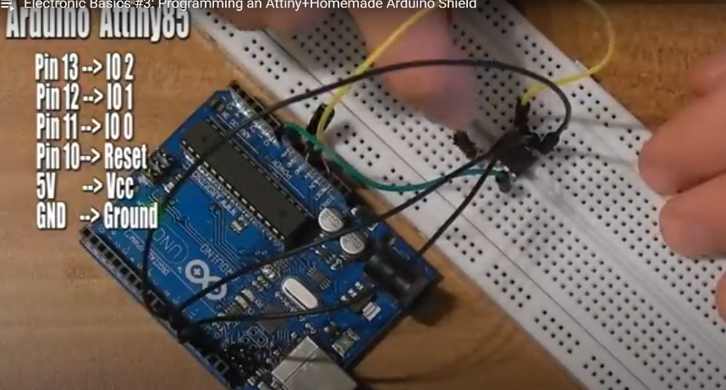For Arduino code, IO 2 AnalogInput 1, IO3 AnalogInput 2, IO 4 AnalogInput 3, IO 1 PWM and IO 0 is also PWM.
* Wiring with the Arduino with ATtiny, a 10 microfarad capacitor also be used between GND and reset pin.

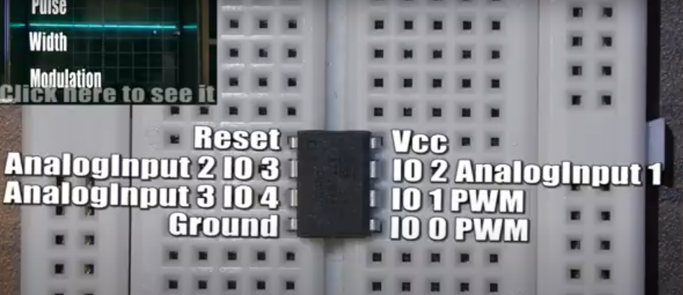

Video 4: Use of Bluetooth module and Arduino with Android

* For Arduino, it uses 5V level and Bluetooth module uses 3.3V levels.
* TX= Transmit pin, RX= Receive pin, BT=Bluetooth.
* For working compatibility, it needs 2 resistors. 2kΩ and 4.7k Ω. So, the connections: TX of BT module with RX of Arduino, TX of Arduino with 2kΩ, GND of Arduino to 4.7kΩ, RX of BT module in the middle of the resistors.
* Using RGB LED which has 4 pins. There are 1 anode and 3 cathodes. As for the wiring, Connect Arduino Pin 8 9 10 with R G B respectfully and Anode with 5V.
* Download the App named S2 Terminal for Bluetooth
* After writing codes, upload it and make sure that RX and TX is disconnected. After completing upload, connect the RX TX again.

Video 5: Multiplexing

* Arduino, P Channel MOSFET(F9540N), TLC594 LED driver, 2kΩ(1pc), 1kΩ(5pcs) is required to control many LEDs.
* Build a PCB with LEDs and connect all positive pins in one row and all negative pins in one column, and thus made LED matrix. For all row and column, add female headers.
* The MOSFET is using as switch. Using 5 MOSFETs.
* For TLC, download libraries and paste it to the Arduino folder.
* After the connections and uploading the Arduino code, moving lights can be seen through the LEDs.
* Code: <https://www.mediafire.com/download/asi6yba4l8844qx/Electronic_Basics#5_Multiplexing.rar>

Video 6: Making Standalone Arduino circuit

* Needed 4 extra components 16 Mhz clock crystal, two 22 picofarad capacitors, one 10kΩ which connects reset pin of ATmega and 5V.
* The resistor connected with ATmega’s reset pin, crystal connects to pin 9 and 10 and also connect capacitor to each pin. Then connect pin 7, 20, 21 to 5V, pin 8 22 to GND. Thus a Arduino is made on a breadboard.
* 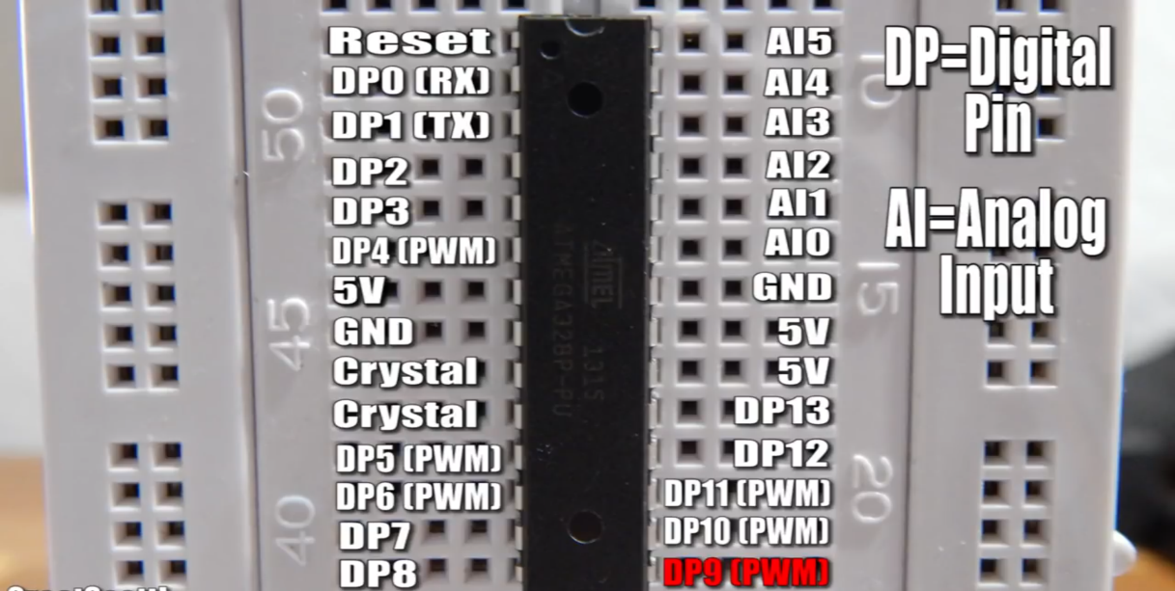There are disadvantages: No reset switch, only 5V input, no USB , no short circuit and overvoltage protection.

Video 7: Use of 7 Segment Display